Execution using UI.

Random places of the battleships and destroyers (initial positions).

Random setup 1.

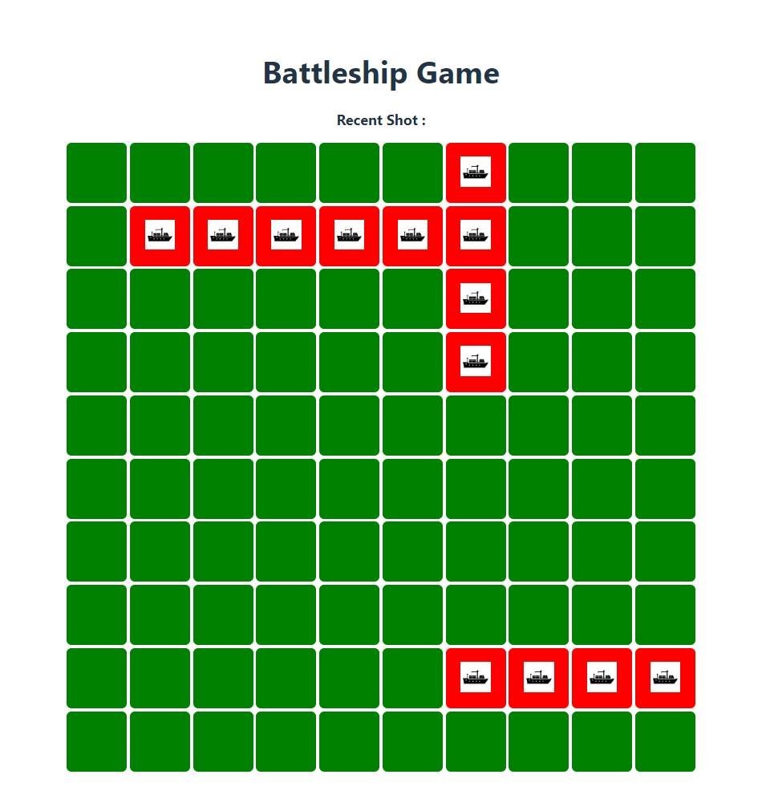

Random setup 2

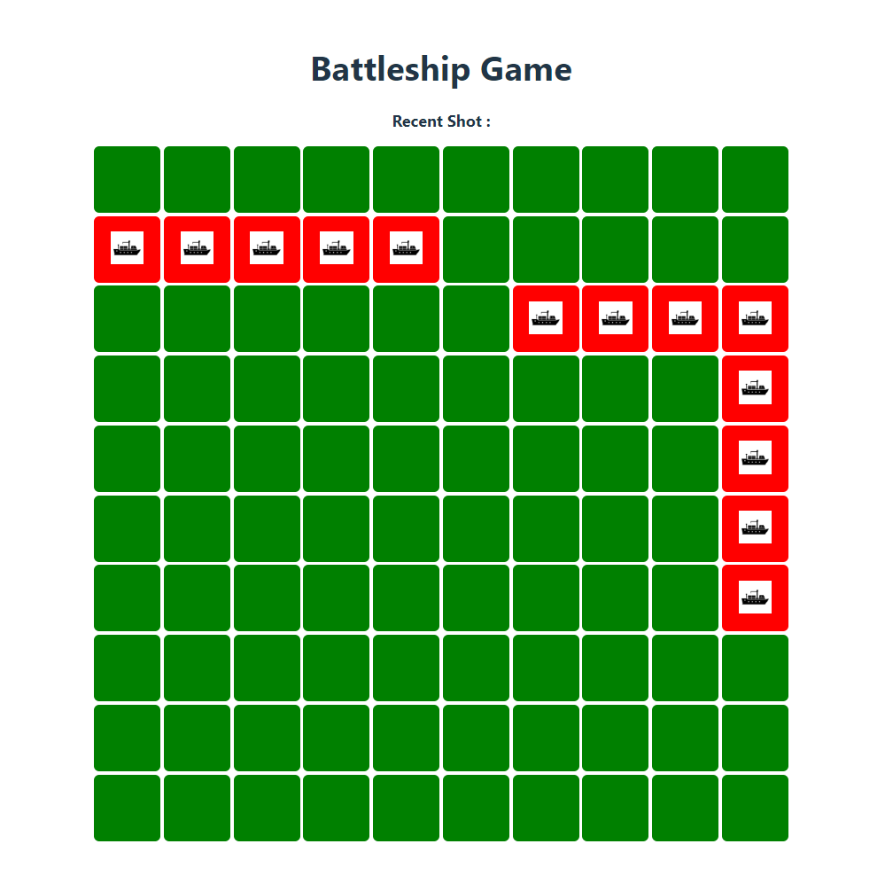

FireCannon method execution – Miss hit

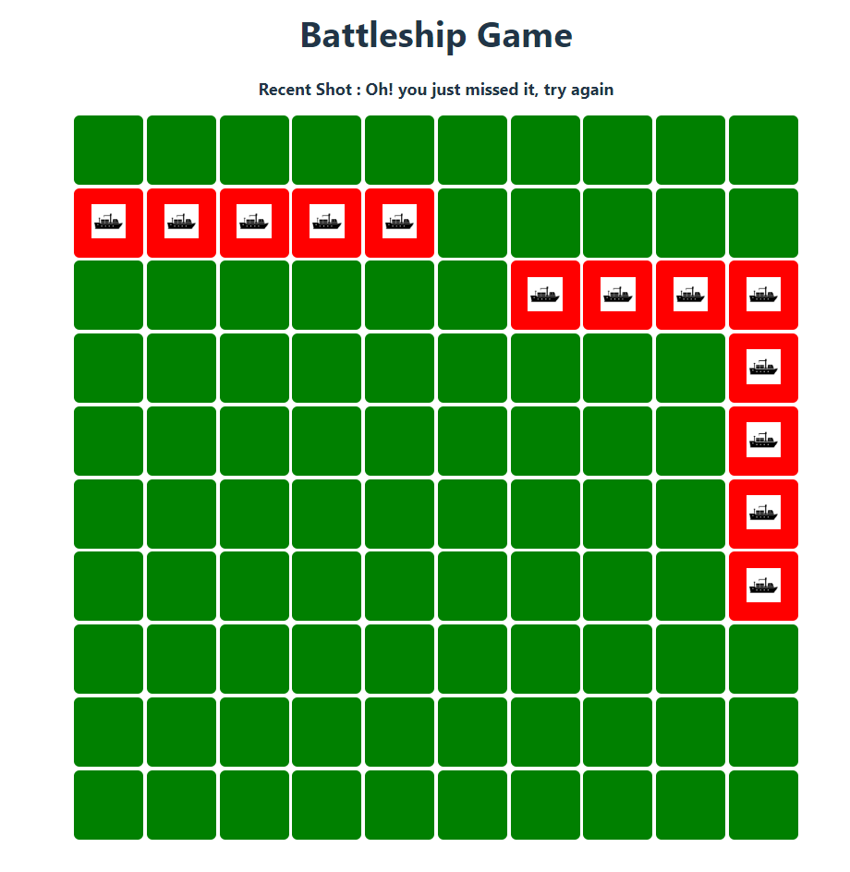

FireCannon method execution – Successful fire

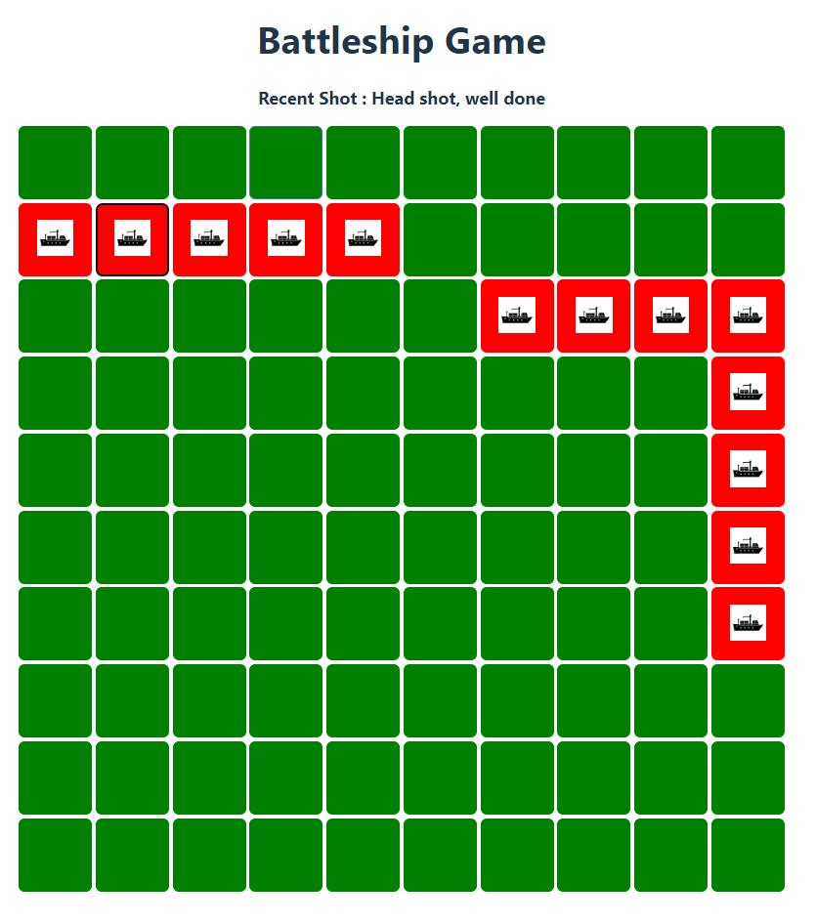

FireCannon method execution – Already hit place

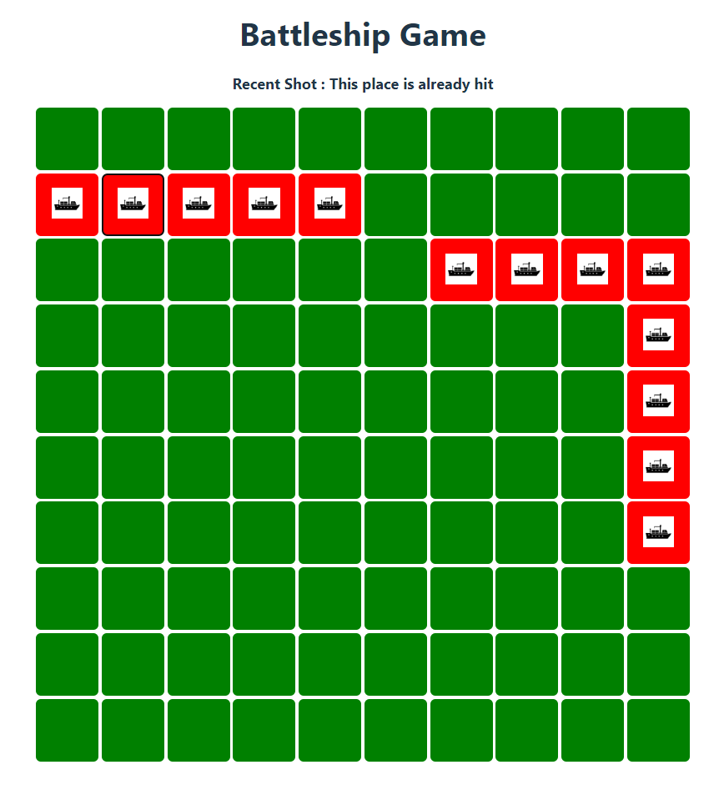

FireCannon method execution – Sunk ship

